**Screen Mockups**

**During Competition:**

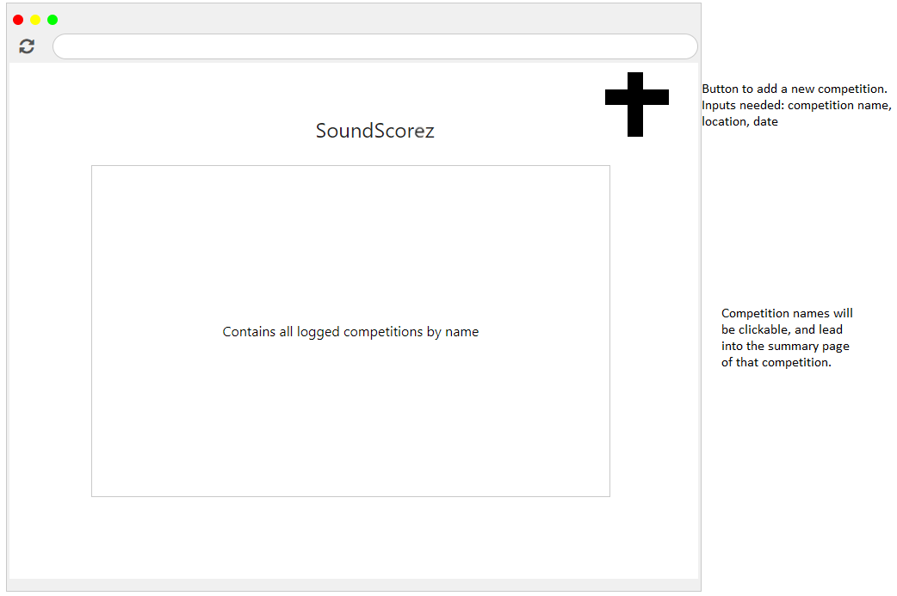

*Main Screen*

This will be the first screen the user sees when they log in to the application for scoring. The user can click on a logged competition in order to add more entries or export the scores for that competition. To create a new competition, the user will select the plus sign in the top right corner, and create a new competition using the competition name, location, and date.

Next, they will be on the Summary Screen for the new competition, or the competition they selected from the log.

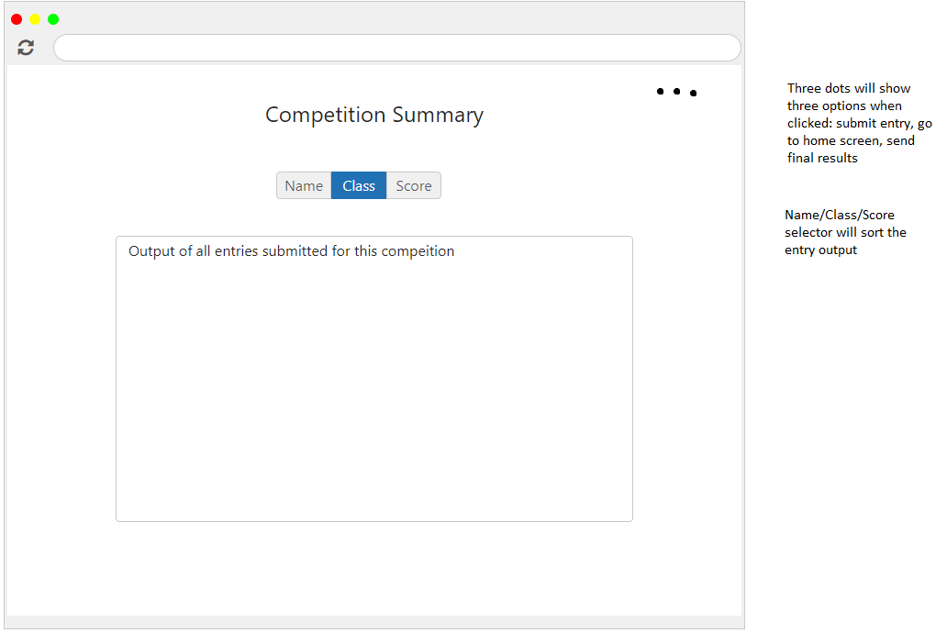

*Summary Screen*

The competition summary screen is where the user can see at a glance all of the entries booked so far for the competition. To add a new entry, go to home screen, or send final results, the three dots at the top of the screen must be clicked. To edit an entry, click on the entry in the output field.

If an entry is to be added or edited, the user will be taken to the Input Screen.

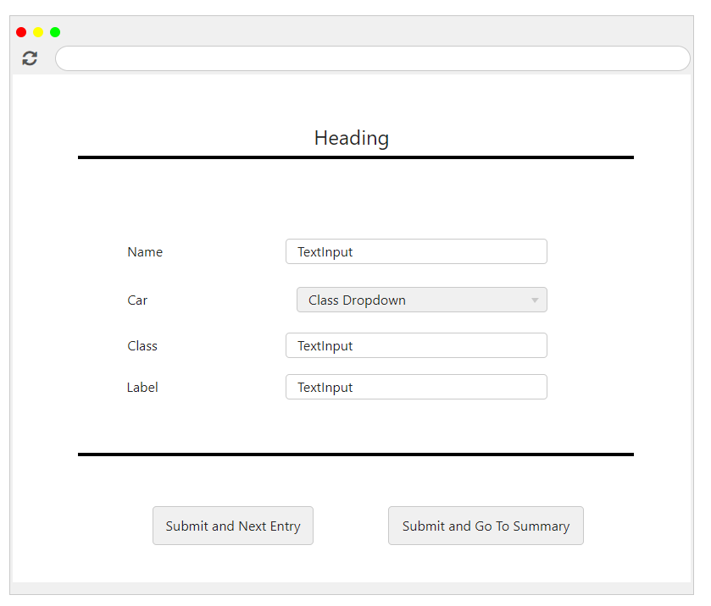

*Input Screen*

This is the screen the user will use to edit or add a new entry. After the required inputs have been satisfied, the user will choose to either submit and return to the same screen for the next entry, or submit and go back to the summary screen.

During the competition, competitors will be able to see their scores on the standings screen.

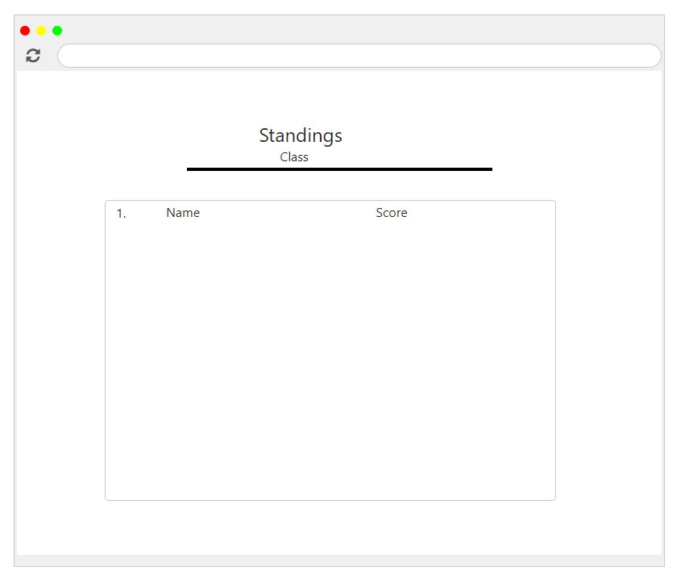

*Standings Screen*

Also during the competition, the user will be able to make use of the Look Up screen to search for an entry by class and name.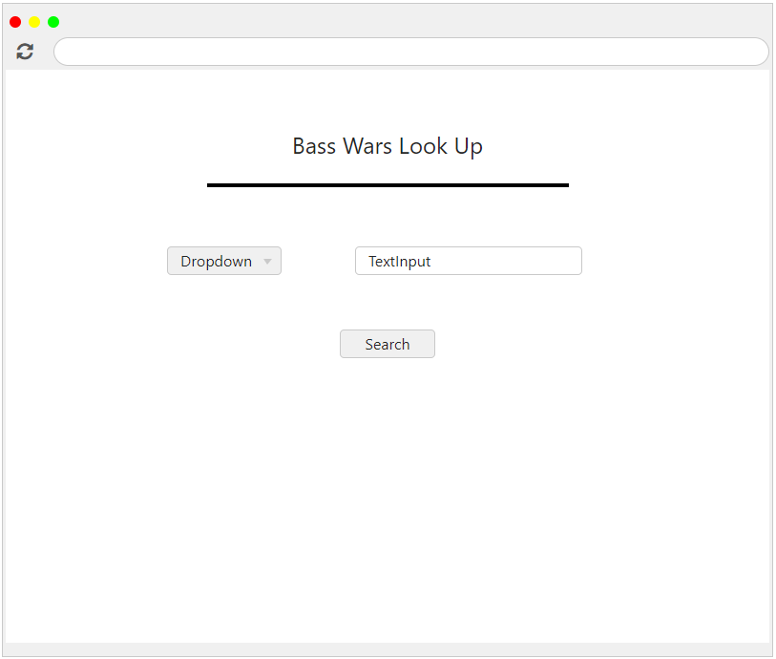

*Look up Screen*

**After Competition:**

The user will upload the exported final scores to the website for formatting and publishing.

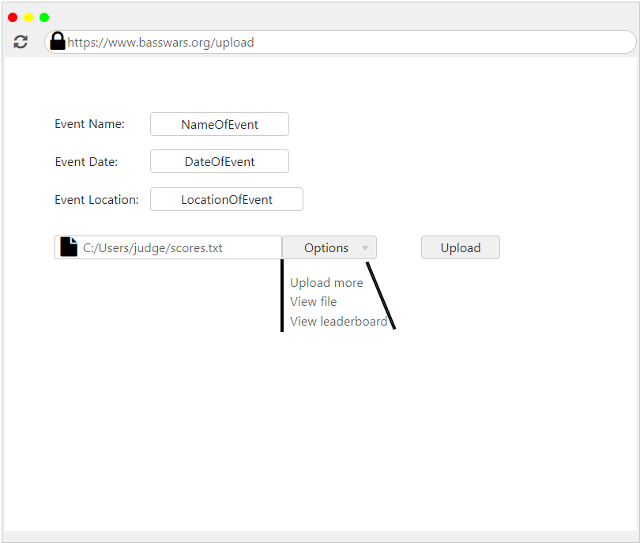

*Upload Page*

This will be formatted automatically into the Winners Screen, so that competitors and judges can easily see the results of the competition.

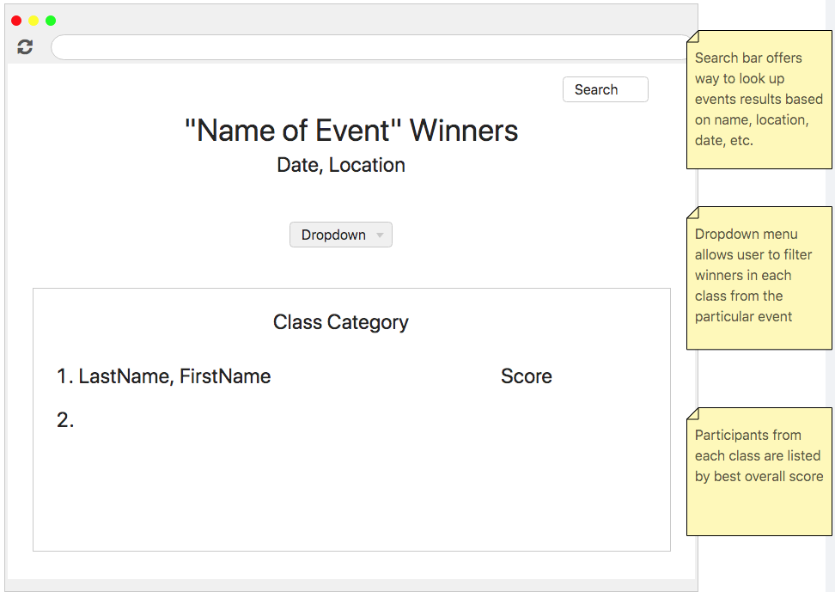

*Winners Screen*

All competitions will be saved in a backup database that way previous competitions will not be lost.

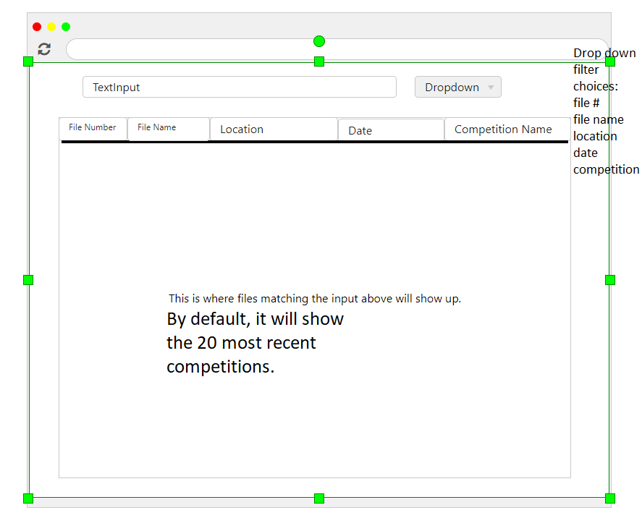

*Backup Page*

For training and reference for new judges, the tutorial page will also be available on the website.

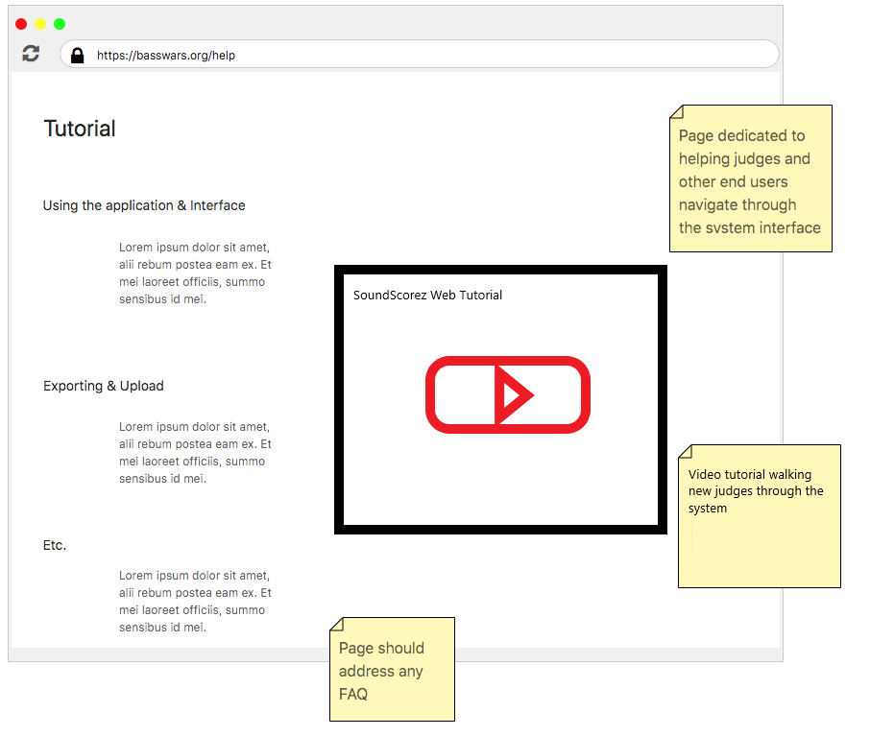

*Tutorial Page*